2025 MULANJE DISTRICT JCE MOCK EXAMINATIONS

MATHEMATICS
Subject Number: J0131
Friday, 4th April Time allowed: 2hours
08:00 am-10:00am
(100 marks)
Instructions
Question number | Tick if answered | Do not write in these columns
1
2
3
4
5
6
7
8
9
10
11
12
13
14
15
16
17
18
19
20
- This paper contains 11 pages. Please check.
- Attempt all questions in this paper
- The maximum number of marks for each answer is indicated against each question.
- Write your name at the top of each page of your question paper in the spaces provided.
- Write your answers in the spaces provided on this paper
- In the table provided on this page, tick against the question number you have answered.
- All working must be clearly shown Turn over

- a .Given that $a=-3, b=2$ and $c=-1,$ work out $\frac{a-c}{abc}$.

(3 marks)
b. A mathematical instrument box has a mass of 273 g. If its relative density is 2.1,
calculate the volume of the mathematical instrument box.

(3 marks)
- a. Simply ${\left( \frac{x^{0}}{y^{-1}} \right)}^{2}$

(3 marks)
b. Given that a bag has y green balls and 12 red balls. If the probability of picking
a green ball is $\frac{1}{4}$ , calculate the value of y.

(4 marks)
- a. In the Figure 1 below QT is parallel to RS, RQ = QS and angle SQT= 65°.
Find angle PQT. P

Q T
65º

R S

(3 marks)
b. If 8 people can dig a trench in 6 hours, how long will it take for 12 people to dig the same trench?

(3 marks)
- Solve the inequality $7 ≤2x +1<0$ , and show the results on a number line.

- marks)

- a. Convert 13201₄ to base 10.

(3 marks)
b. Equation of a line is given by$-y-3x=2$. Find gradient of the line

- marks)
- Factorise completely ${tc -nr-cr+nt}^{ }$

(4 marks)
- The interior angle of a regular polygon is 4 times the exterior angle. Name the polygon.

- marks)

- Make $x$ the subject of the formula $x-t= \frac{yx}{r}$

(4 marks)
- Mr Phiri has children whose ages form a sequence: 11, 9, 7, … Find the n^{th} term.

(3 marks)
- Using logarithms, calculate the value of $\frac{5.25}{1.14 x 2.1}$, leaving your answer correct to 4 significant figures.

(6 marks) 11. Figure 2 shows triangles in which AB is parallel to DE and AC = CE. 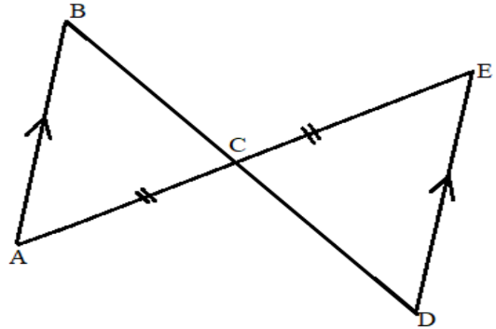
Figure 2
Prove that BC = DC

(4 marks)
- Solve the following simultaneous equations.
$$2x=1+y$$
$x+y=5$

- Marks)

- The table below shows rate of income tax an employee pays at a company
Income per month | Rate of tax
First 4,800 | 0%
Next 9,600 | 10%
In excess 14, 400 | 25%
Calculate the income tax payable by a person who earns K 48,800.

(5 marks)
- A 6.5 m ladder rests against a vertical wall of a building. The foot of the ladder is 2.5m from the base of the building. How high up the wall does the ladder reach?
L

6.5 m

B 2.5 m F

(4 marks)
- At a car park, there were 20 cars in the categories of Toyota, Mazda and Nissan. Their
numbers are as shown in table below
Type of Vehicle | Toyota | Mazda | Nissan
Number of Vehicles | 12 | 5 | 3

Draw a pie chart to represent the information in the table above

(5 marks)
16. Using a ruler and pair of compasses only, construct in the same diagram
- Triangle PQR in which QR = 6.5cm, PQ = 4.5 cm and angle PQR = 45⁰ ( 4 marks)

- Measure and state PR (1 mark)
17. Solve the equation $\frac{x^{2 }+ 2x}{x^{2}} = \frac{2x + 4}{x- 3}$

(6 marks)
18. Given set A = {1, 3, 4},
a. How many subsets will set have?

(2 marks)
b. list any three subsets of the set.

(3 marks)

19. Figure 3 below shows a right square based pyramid in which PQ = 8 cm and VX =
7 cm.
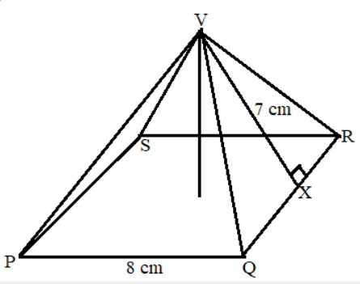
Figure 3
Calculate the total surface area of the pyramid

(5 marks)

20. Motorist X left village N at 6:00 am for village P, 120 Km away. He travels at a speed of 50 Km/hr for 1 hour, and then stopped for 15 minutes before he proceeds to arrive at village P at 9:00am. Motorist Y left village N for P, 1 hour later after X had already left. He travelled non-stop at 80 Km/hr.
a. Using a scale of 2 cm to represent 20 Km and 2 cm to represent 30 minutes,
draw a distance time graph to show the journey of the motorists (5 marks)
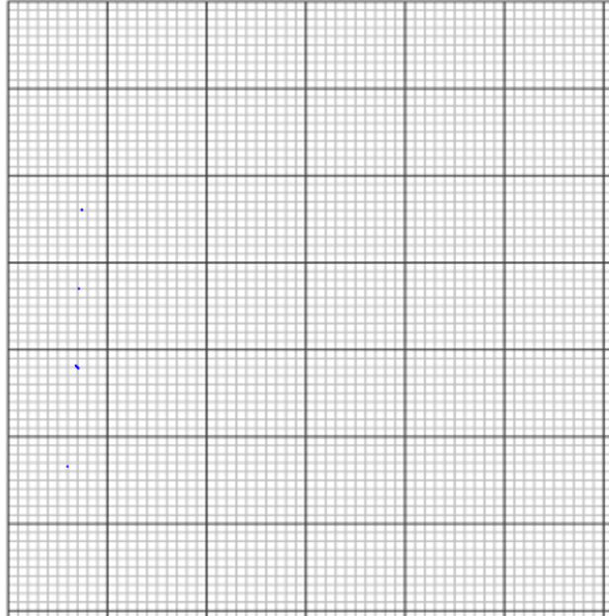
b. Use the graph to find the time at which motorist Y did overtake motorist X
(1mark)
END OF QUESTION PAPER

